Moq handson
Objectives:
- Understand how Mocking can enhance Test-Driven Development (TDD)
  - Mocking, Isolation, Test doubles, Mock Vs Fake Vs Stub, Key advantages of TDD

Test-Driven Development (TDD) is a software development approach in which developers write unit tests before writing the actual application code. The goal is to ensure that the code meets the requirements and remains reliable as it evolves.
TDD follows the Red–Green–Refactor cycle:
- Red: Write a test that fails because the feature has not been implemented.
- Green: Write the minimum code required to make the test pass.
- Refactor: Improve and optimize the code while ensuring all tests continue to pass.
Key Advantages of TDD
- Improves Code Quality
  - Encourages writing clean, modular, and maintainable code.
- Early Bug Detection
  - Bugs are identified during development rather than after deployment.
- Supports Refactoring
  - Developers can modify code confidently because automated tests verify that existing functionality remains correct.
- Better Design
  - Promotes loosely coupled and highly cohesive components.
- Improves Test Coverage
  - Every feature is accompanied by one or more unit tests.

Mocking is the process of creating simulated (fake) objects that imitate the behavior of real dependencies, such as databases, web services, or file systems. These mock objects allow developers to test a class without relying on external resources.

Isolation means testing a single unit (class or method) independently of its external dependencies.

A Test Double is any object that replaces a real dependency during testing.
Common types of test doubles are:
- Dummy: Passed as a parameter but never used.
- Stub: Returns predefined values.
- Fake: Provides a simplified working implementation.
- Spy: Records information about method calls.
- Mock: Simulates behavior and verifies interactions.

Feature | Stub | Fake | Mock
Purpose | Returns predefined data | Simplified working implementation | Simulates behavior and verifies interactions
Logic | Minimal | Contains simple business logic | Configurable behavior
Verification | No | No | Yes
Example | Returns a fixed student name | In-memory database | Checks whether Save() was called
Explain the meaning of Mocking in Unit Testing and why use mocks in Unit Testing
  - Mocking and Isolation in Unit Testing, Isolating dependencies in Tests using Mocks and Stubs
- The main purpose of mocking is to test the business logic of a class independently while controlling the behavior of its dependencies.
Using real dependencies in unit tests can make tests:
- Slow due to database or network operations.
- Unreliable because external systems may be unavailable.
- Difficult to reproduce because external data can change.
Benefits of Using Mocks
- Faster test execution
- No dependency on databases or external services
- Predictable and repeatable test results
- Easy simulation of success and failure scenarios
- Better isolation of business logic
Advantages of Isolation
- Independent unit testing
- Faster execution
- Easier debugging
- Reliable test outcomes
- No external resource dependency
A Stub returns predefined values without verifying interactions.
A Mock allows us to define expected behavior and verify method calls.
- Understand the basics of DI (Dependency Injection) and how dependency injection helps unit testing in applications
  - Dependency Injection, Constructor Injection, Method Injection
Dependency Injection (DI) is a software design pattern in which the objects or services that a class depends on are provided (injected) from outside the class instead of being created inside it. This reduces the dependency between classes, making the application more flexible, maintainable, and easier to test. Instead of a class creating its own dependencies, those dependencies are supplied by another component, such as a dependency injection container or the calling code.
Dependency Injection makes unit testing easier by allowing developers to replace real dependencies, such as databases, web services, or file systems, with mock or stub objects. Since the class no longer creates its own dependencies, testers can inject controlled and predictable objects during testing. This enables unit tests to focus only on the business logic of the class without relying on external systems. As a result, tests become faster, more reliable, repeatable, and easier to maintain. Dependency Injection also promotes loose coupling between components, making applications more flexible and easier to modify.
Types of Dependency Injection
1. Constructor Injection
Constructor Injection is the most common and recommended form of Dependency Injection. In this approach, dependencies are passed to a class through its constructor when the object is created. This ensures that all required dependencies are available before the class starts functioning and makes the dependencies explicit.
2. Method Injection
Method Injection provides the required dependency through a method instead of the constructor. The dependency is supplied only when the specific method is called. This approach is useful when a dependency is needed only for a particular operation rather than throughout the lifetime of the object.

- Demonstrate on how to create a testable code with Moq.
Testable code- Testable code is code that is designed so it can be easily tested in isolation without depending on external resources such as databases, file systems, or web services. Testable code follows principles such as loose coupling and Dependency Injection (DI), allowing dependencies to be replaced with mock objects during unit testing. This makes tests faster, more reliable, and easier to maintain.
- Demonstrate on how to create a mock object that access database for unit tests
  - Mock database for Unit Tests
- Demonstrate on mock object that access the file system for unit tests
  - Mock files for Unit Tests

- Write Testable Code with Moq
Scenario
You are tasked to write a unit test code for the below scenario.
The application in which you are teamed up with, deals with a mail server communication in which your application tries to send mail to its users upon every transaction. Your role is to write unit testing the module that contains send mail functionality. You wanted to perform testing the module without sending any email.
After investigating the problem scenario, you found a solution and that is creating mock objects of these external dependencies in the unit testing project so that you can achieve speedier test execution and loose coupling of code.
Note: Duration to complete this exercise is 30 min.

Task1

In this task, you will create a class library that will be used for unit testing.
- Create a Class Library (Language C#) project using Visual Studio IDE, and name it as CustomerCommLib.

- Rename the default Class1 class name as MailSender.

- Include the following namespaces with ‘using’ directive.

  - System.Net
  - System.Net.Mail

- Define an interface as follow.

public interface IMailSender
{
bool SendMail(string toAddress, string message);
}

- And provide implementation of IMailSender in the MailSender class as seen below.

namespace CustomerCommLib
{
public class MailSender:IMailSender
{
public bool SendMail(string toAddress, string message)
{
MailMessage mail = new MailMessage();
SmtpClient SmtpServer = new SmtpClient("smtp.gmail.com");
mail.From = new MailAddress("your_email_address@gmail.com");
mail.To.Add(toAddress);
mail.Subject = "Test Mail";
mail.Body = message;
SmtpServer.Port = 587;
SmtpServer.Credentials = new NetworkCredential("username", "password");
SmtpServer.EnableSsl = true;
SmtpServer.Send(mail);

}
}}
The above class can’t be unit testing since the code access the STMP mail server.
- Create another class called CustomeComm which is the class under test in the given scenario.
namespace CustomerCommLib
{
public class CustomerComm
{
IMailSender _mailSender;

public CustomerComm(IMailSender mailSender)
{
_mailSender=mailSender;
}
public bool SendMailToCustomer()
{
//Actual logic goes here
//define message and mail address

_mailSender.SendMail(cust123@abc.com,”Some Message”);

return true;
}
}
}
In the above code we injected the dependency (IMailSender) through constructor of CustomerComm class so that we can pass the mock object of the dependency wherever it is necessary.
We have successfully created a class that's written in such a way that we can run a unit test against it and an exception won't be thrown. We achieve this by mocking the call to IMailSender.SendMail() and adding a mocked return value of true to it.
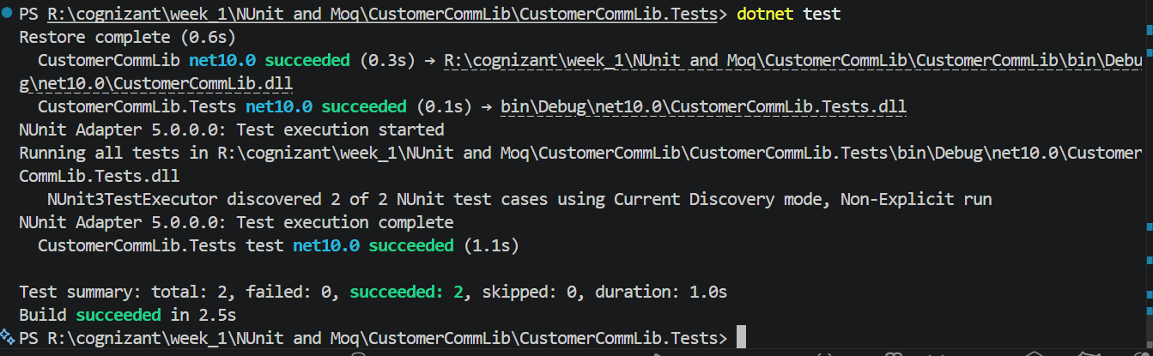
- Finally build your project and be ready for the unit testing with NUnit and Moq.

Task2
In this task, you will create unit test project which make use of NUnit framework and Moq.
- Create a new class library project called CustomerComm.Tests and add the following external dependencies to it using NuGet Package Manager.

  - NUnit , NUnit Test Adapter , Moq
- Add the references of assemblies as appropriate including CustomerCommLib.
- Write unit test code and mock the MailSender (IMailSender) class.
- Use TestFixture, OneTimeSetUp and TestCase attribute classes on top of test class, init method and test method respectively.
- Configure the mock object in such away that SendMail() method will accept any two string arguments and always return true when SendMailToCustomer() gets invoked.
- Finally assert the return value to “true”.
